NAME: ____________________________________

General English Task 11: In class short answer section
Working time for the task: Preparation: 10 minutes. Read the paper.
Students may ask questions and take notes during this time. Working: 2x40 minutes
Total marks: Marked out of 30
One section of Task 11

Questions 1 – 3 are about understanding of biographies in general.
Questions 4 and 5 ask you to read two short extracts from biographies and explain their main ideas and construction.
Question 6 asks you to annotate, summarise and complete a retrieval table to explain a film poster for a biography.
The marks for each question are given in brackets.

FINAL TOTAL: ___________/30

- Explain why we study biographies. (2 marks)

- Fact and opinion – Explain the difference, giving examples from biography to support your answer. (2 marks)

- ‘The focus of a biography affects our interpretation of the subject.’
Explain what this means. (3 marks)

- Read the following text, ‘Jimmi Hendrix 1992 Performer’ and answer questions (a) and (b). (5 marks total)
Text 1: Jimi Hendrix 1992, Performer
Jimi Hendrix expanded the range and vocabulary of the electric guitar into areas no musician had ever ventured before. Many would claim him to be the greatest guitarist ever to pick up an instrument. At the very least his creative drive, technical ability and painterly application of such effects as wah-wah and distortion forever transformed the sound of rock and roll. Hendrix helped usher in the age of psychedelia with his 1967 debut Are You Experienced and the impact of his brief but meteoric career on popular music continues to be felt.

More than any other musician, Jimi Hendrix realised the fullest range of sound that could be obtained from an amplified instrument. Many musical currents came together in his playing. Free jazz, Delta blues, acid rock, hardcore funk, and the song writing of Bob Dylan and the Beatles all figured as influences. Yet the songs and sounds generated by Hendrix were original, otherworldly and virtually indescribable. In essence, Hendrix channelled the music of the cosmos, anchoring it to the earthy beat of rock and roll.
(Rock Hall of Fame)
- What view of the subject is encouraged in Text 1? (2 marks)

- Explain how the text positions the reader to think this way. (3 marks)

- Read the following text, ‘Ned Kelly’ and answer questions (a) and (b). (5 marks total)

Text 2: Ned Kelly
Sunrise was at 7:17 am. The kookaburras of the Warby Ranges cleared their throats to greet its first rays with the greatest shout of laughter they had ever emitted – a cacophonic chorus at human folly – for now there would be enacted, a few minutes before the sun jumped up, one of the most fantastic scenes ever witnessed by human beings or kookaburras in the wide land of Australia.
Ned Kelly, after lying encased in his armour on the frosty ground in a welter of his own blood for three and a half hours, came fully to his senses at seven o’clock, and decided to return to the battle.
Desperately wounded as he was, weakened by loss of blood, and his limbs frozen, he, by an almost superhuman effort, managed to stand erect and to walk, encumbered by a hundredweight of iron, not away from the fight, in the direction of possible safety for himself, but back to the hotel to rescue his mates.
It was at that moment and by that decision, that Ned Kelly’s name was fixed in Australia’s lore as the proverbial symbol of reckless courage.
As game as Ned Kelly.
This was the supreme moment of his life, and he perhaps knew it. At the age of twenty-five he took the decision to go down fighting.
(The Kelly Hunters by Frank Clune p292)
- What view of the subject is encouraged in Text 2? (2 marks)

- Explain how the text positions the reader to think this way. (3 marks)

- Film poster
- Annotate the following film poster, identifying the visual conventions used.
- Write a summary of the key ideas in this poster.
- Complete the retrieval table explaining three main techniques used and their effect on meaning. (9 marks total)

(a) Annotate visual codes and conventions in the poster. (3 marks)

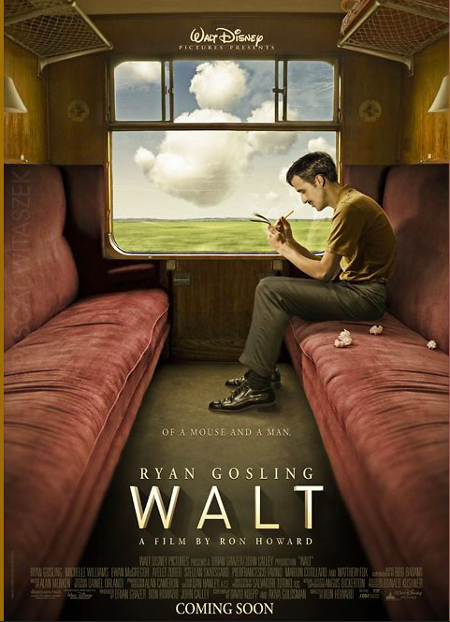

(b) Summarise the key ideas of the poster. (2 marks)
(c) Complete the retrieval table. (8 marks)
Retrieval Table – ‘Walt’
Technique | Description | Effect on meaning

